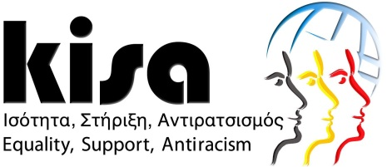

Participation Form

Seminar: Strategies and action plans on racism, violence against women, gender equality and migration: Their intersections and how they concern and influence migrant women
Sunday, 9 March 2015 10:30am – 16:00pm
Holiday Inn, Nicosia
http://www.holidayinn.com/hotels/us/en/nicosia/niccy/hoteldetail
Name and Surname:
Organisation:
Email:
Telephone number:

Please send the completed participation form to info@kisa.org.cy or confirm by calling KISA on 22878181.
Thank you!
